**Criterion A – Planning**

1. *Defining the problem*

I have always been a big fan of music for the past few years, but not of just the music: all aspects of the music industry: lyrics, producers, sound samples, artist image, song titles, and, most importantly, album artworks. Just like their artists, album artworks manage to provide the background, the setting, the tone for the entire series of songs in the album to follow. They may be carefully structures or contrived out of spontaneity. I’ve always had the desire to make album artwork for the songs that I’ve created to give them a more authentic and holistic feel.

While similar programs exist online to produce symmetrical patterns and kaleidoscopic designs, random and inspired designs are scarce. These online programs don’t disseminate the true spirit of randomness and spontaneous discovery, so I hope that this program will give the client, myself, the ability to create and get inspiration for album artwork choices in a truly haphazard fashion.

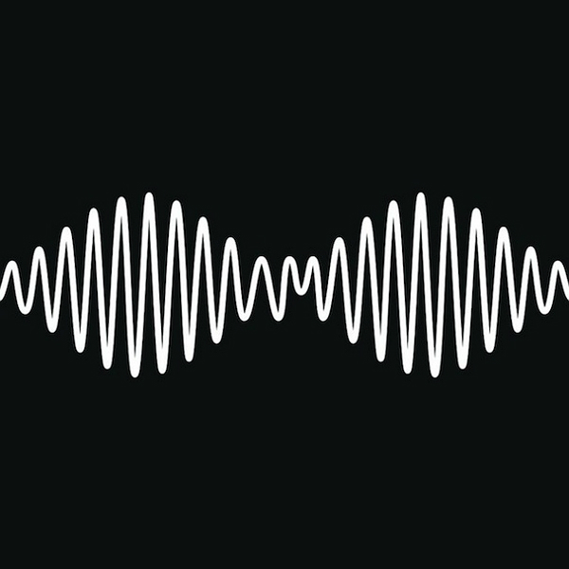

*Picture 1: Arctic Monkey’s* ***AM*** *Album Artwork.* (Picture taken from <http://static.gigwise.com/artists/ArcticMonkeysAM600.jpg>)

1. *Rationale for Solution*

Many abstract artworks may be spontaneous with capturing a picture moment or expressing the thought through human hand, but a computer equivalent would be done by randomization of parameters and algorithms/requests from the user. With the assistance of my advisor, Mr. Balcar, my IB Computer Science teacher, I will design and program a Random Artwork Generator (RAG) so that users can randomly create computer-algorithm based artworks for aesthetic purposes, either entertaining or functional. The user will be able to control different types of settings that will dictate some aspects of the final art-piece while other factors will be randomized so that each individual art piece that is generated will be truly unique (or at least rare enough to generate again by repeating the same settings and conditions). This RAG will allow clients, primarily myself, to create random artworks without the tediousness of using digital art to make them or stress of brainstorming ideas for them.

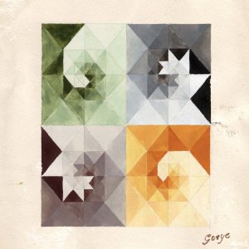

Picture 2: Gotye’s **Mirrors** Album Artwork. (Picture taken from <https://upload.wikimedia.org/wikipedia/en/thumb/9/95/Gotye_-_Making_Mirrors.png/220px-Gotye_-_Making_Mirrors.png>)

1. *Criteria for Success*

* The client will enter a main screen where they can make multiple selections for what the image pattern will follow.
* Within each selection, options will follow to diversify the randomness and various settings and properties of the final image.
* There will be default settings with initialized values and parameters that have limiting values within each option.
* Selections may vary from: Album Artwork Inspirations (The Beatles’ 1, Gotye’s Mirrors, Arctic Monkeys’ AM, etc.), gradual gradient shift, geometric mess, etc.
* Properties may vary from: initial color hue, final color hue, rate of change, size of frame, shapes used, etc.
* The final image will be produced using GUI and JFrame methods.

Word Count: 459